. Check every Monday -AWS Backup status for all accounts

1. Login to <https://628471438687.signin.aws.amazon.com/console>.
2. Switch **to SAP_NONPROD++|++852956782656** (same check for **SAP_PROD** And **Shared_services**)

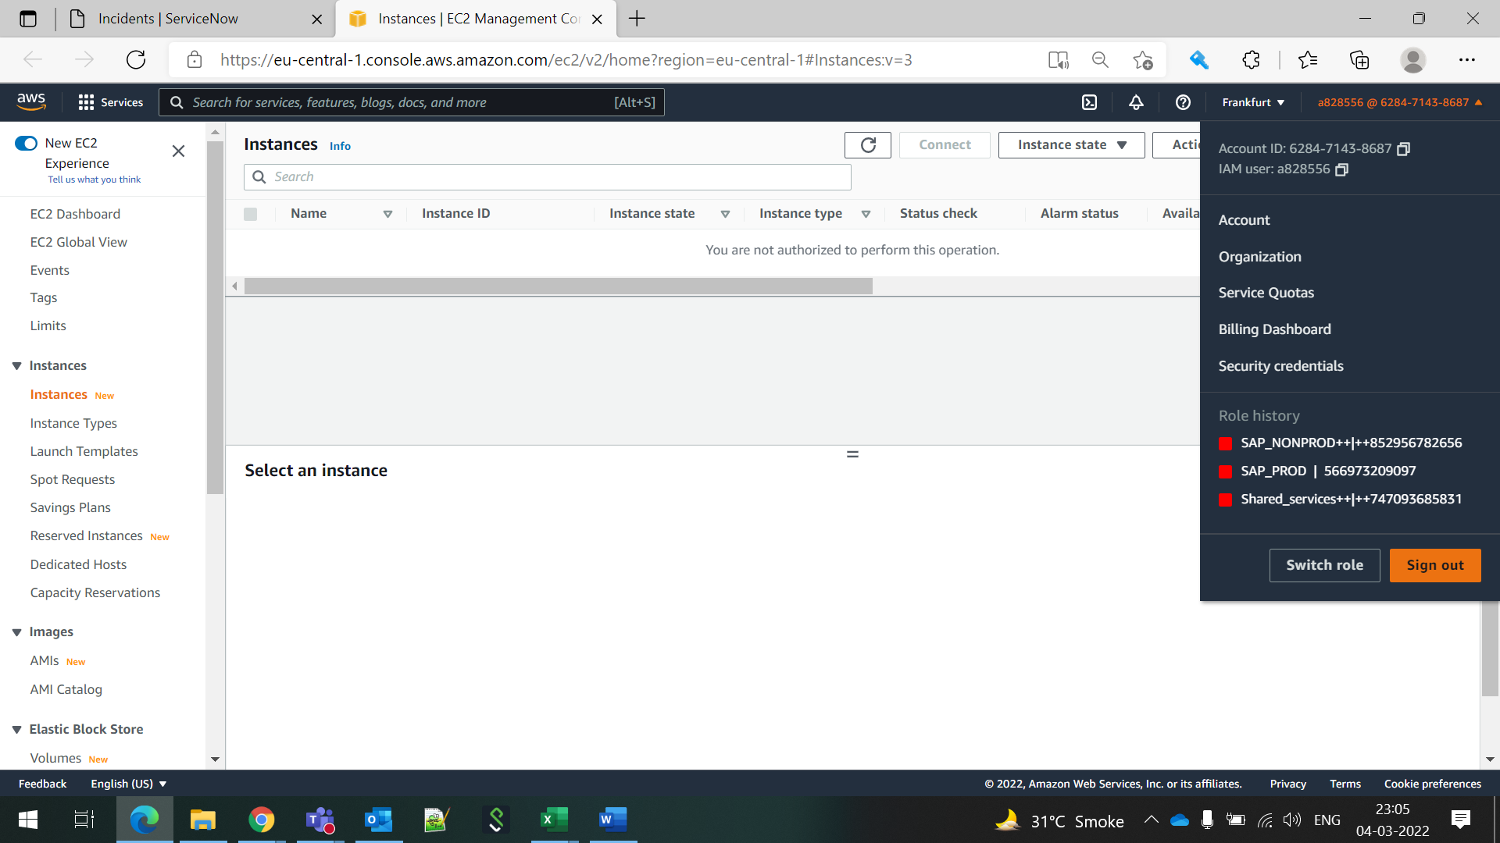



3.Search for AWS Backup.



4.On left panel click on Dashboard you will see Backup Jobs in last 24 hours and monitor completed , failed , in progress.

